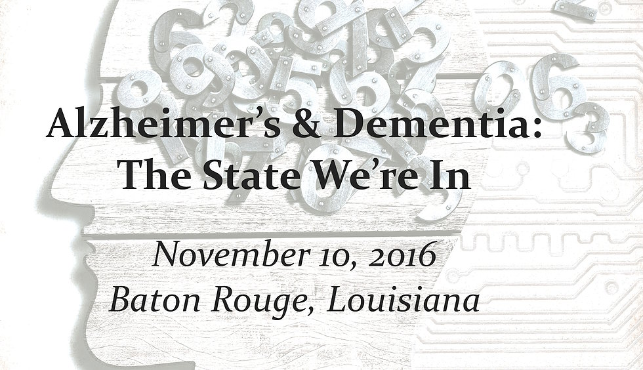

An Update on Alzheimer’s & Other Forms of Dementia: The State We Are In An informational event presented as a public service by the Environment & Health Council of Louisiana, a 501(c)(3) nonprofit organization
November 10, 2016 8:00 am – 2:00 pm Pennington Conference Center, Baton Rouge, LA
AGENDA
8:00 Registration & Coffee
Exhibition Hall
8:30 Welcome & Opening Remarks
Layna Rush, President EHCL Dr. Phillip Brantley, Pennington Biomedical Center
8:45 Understanding Dementia Dr. Katie Cherry, Louisiana State University
9:15 Caregiver Challenges panel
Dr. Territo, QDCP, Alzheimer’s Services of the Capital Area Mary Ann Olivier, Caregiver John McManus, Caregiver
10:15 BREAK Exhibition Hall
10:35 Elder Law Issues Linda Melancon, Legacy Center of Louisiana, LLC
11:20 LUNCH Fit NOLA Healthy Meals presentation
11:45 Lunch Speaker TBD
12:15 Keynote Address: Update on Detection & Treatment Options
Dr. Patrick Gahan, Pennington Biomedical Center
1:00 Lifestyle Choices & Resources panel
Dr. Owen Carmichael, Pennington Biomedical Center Barbara Auten, CFRE, CAP, Alzheimer’s Services of the Capital Area Dr. Jan Hondzinski, Louisiana State University Frances White, PACE Baton Rouge

